Lab 7: Spatial Analysis and Raster Processing

Using geoprocessing tools to analyze raster data

Geospatial Operations Support Team

(GOST)

Katie McWilliams

Benjamin Stewart

GOST@worldbank.org

**Part 1: Working with Raster Data**

*The goal of this exercise is to become familiar with raster data and processing. You have been asked to assess the effects of sea level rise on both the population and livelihood of Bangladesh. To do so, you will work with three raster datasets: A land cover classification derived from SPOT imagery, A Digital Elevation Model (DEM), and a raster of population count for the year 2012 created by Oak Ridge National Laboratory’s Landscan project.*

*Land Cover- SPOT: The land cover dataset is the GLC2000, 1km resolution land cover map derived from the vegetation sensor onboard the SPOT 4 satellite. The dataset is freely available, and was downloaded from the European Commission Joint Research Centre, Global Environment Monitoring Unit. It is available at:* <http://forobs.jrc.ec.europa.eu/products/glc2000/glc2000.php>*.*

*Landscan: a population dataset that shows the distribution of the human population at a resolution of roughly 1km. The dataset is proprietary, purchased by the World Bank in 2012. IT CANNOT BE SHARED OUTSIDE THE WORLD BANK GROUP.* [*http://web.ornl.gov/sci/landscan/*](http://web.ornl.gov/sci/landscan/)

*DEM_SRTM (The Shuttle Radar Topography Mission) obtained elevation at near-global scale to generate the most complete high-resolution digital topographic database of Earth. DEM data can be downloaded from* <http://www.cgiar-csi.org/data/srtm-90m-digital-elevation-database-v4-1>.

1. Open a new, blank ArcMap document.
2. Click on the ‘add data’ button and navigate to the Lab 7 folder on your desktop. You should see three rasters:

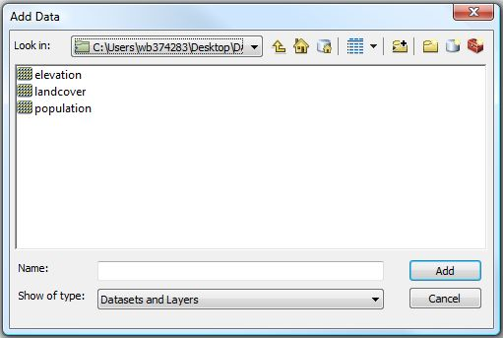

1. Holding down the control key, click on each file to add all three to the map display.
2. Once the files appear in the table of contents, go to File > Save As and save your map within the Lab 7 folder. **Remember to save periodically throughout the exercise.**
3. The default coloring for a raster is usually a white/black color ramp. Let’s begin by adjusting the colors of the population raster. First, uncheck the land cover and elevation layers to turn them off.
4. Double click (or right click and go to Properties) on the Population layer. Go to the Symbology tab.
5. 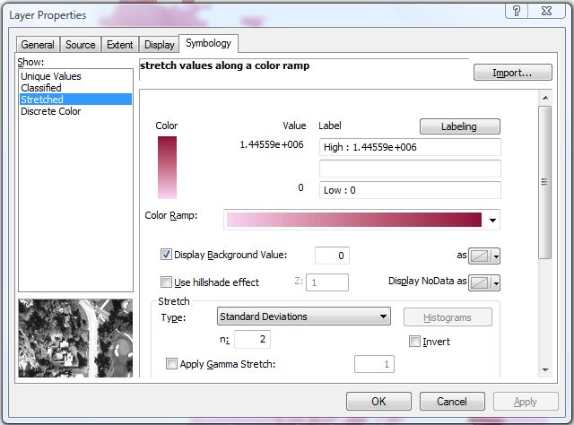Choose a brighter color from the color ramp. Then, in the box below the color ramp, check ‘Display Background Value.’ The value for this setting is set by default to ‘0’ and transparent. This means all cells with a zero value will be transparent.
6. Click OK. Your raster should have a much nicer appearance.
7. Turn off the population layer, and turn on the landcover layer. Double-click on the layer name to open the properties.
8. On the Symbology tab, under the Show column on the left side click ‘Unique Values’. Change ‘VALUE’ to ‘TYPE’ in the Value field, and then click ‘Add All Values.’ Finally, choose a color ramp from the drop down menu. When your screen looks similar to the one below, click OK.

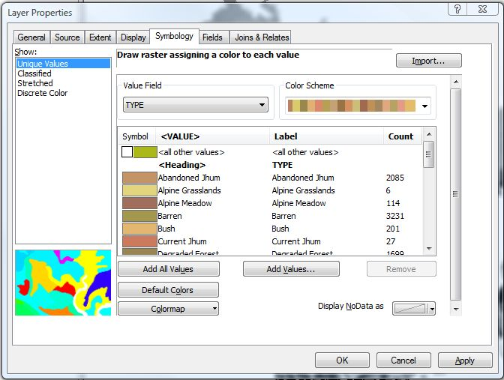

1. Finally, turn off the land cover layer and turn on the elevation layer. Double click (or right click and go to Properties) on the Elevation layer. Go to the Symbology tab.
2. Since we are going to focus on areas that are less than 10m above sea level, we will use Symbology to highlight those areas.
3. On the left-hand side of the dialogue box, (in the ‘show’ column) click ‘Classified.’ Natural Breaks should be listed in the middle as the default classification scheme. Change the number of classes to 4. Your layer properties screen should look like this:

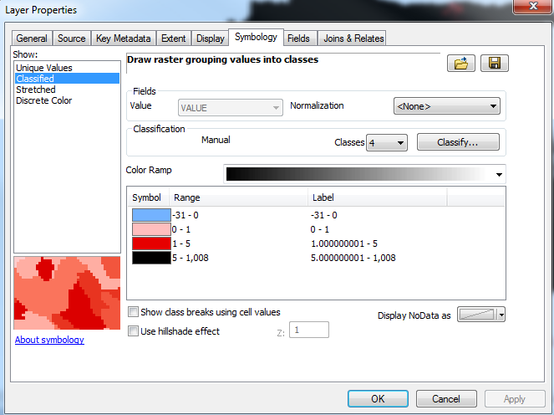

1. To highlight those areas less than 5 meters, click on the ‘classify’ button (outlined in red above).
2. In the Break Values box on the right, change the value settings so they match the following graphic:

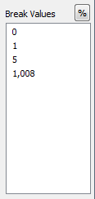

1. Click OK to return to the layer properties menu.
2. Change the symbology of the new classes by double clicking on each color. Set the lowest class to blue (water), set the middle two classes to shades of red (to represent the two sea level rise scenarios), and set the top class to something gray. Click OK. Your output should look similar to the picture on the following page.

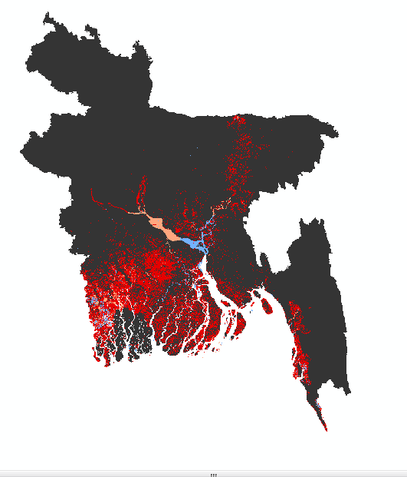

**Part 1.3 - Working with the Raster Calculator and Zonal Statistics**

*Now that our files are symbolized, our first task is to identify only those areas that are within one meter and five meters of sea level. To do so, we will use a tool called the Raster Calculator.*

1. On the top menu bar, go to Customize > Extensions. ArcGIS offers different extensions for different versions of the program (Basic, Standard, and Advanced). Make sure that the box next the Spatial Analyst extension is checked. Then click close.
2. In ArcToolbox, go to Spatial Analyst Tools > Map Algebra. Double-click on the Raster Calculator tool.
3. We want to select those pixels in the elevation layer that are at or below one meter, so use the calculator wizard to build the following expression: “elevation” <= 1.
4. In the output raster box, save the new file within your Lab 7 folder as 1mRise. Your window should look like this:

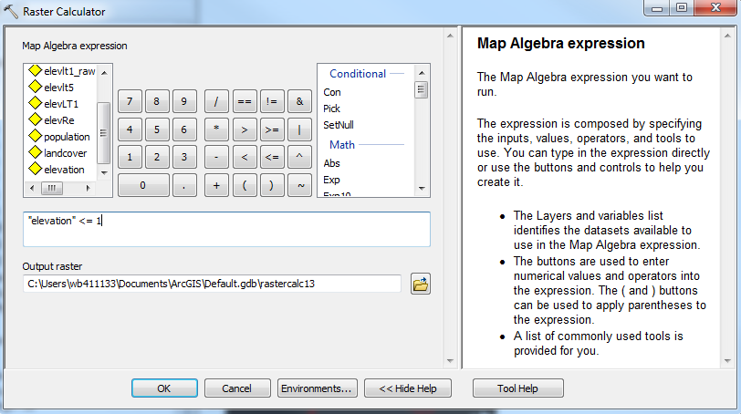

1. Click OK, and wait while the tool processes. When it is finished, the new 1mRise raster should appear in the map display.

*NOTE: The raster calculator separates the input raster into 2 categories: those that ‘fit’ the condition, and those that do not. In this instance, those pixels that ‘fit’ the condition (those that had an elevation less than 1m) were assigned a ‘1’ value in the output raster. Those pixels that did not fit the condition (the pixels with elevation greater than 1m) were assigned a ‘0.’ Therefore, the 1mRise raster should only have 2 attributes: pixels that fit the condition and pixels that did not.*

1. Now repeat the process to highlight those areas that are at or below 5 meters. Reopen the raster calculator tool, and in the dialogue box enter the map algebra expression “elevation” <= 5. Name the output file 5mRise and click OK to run the tool.
2. Turn off the other layers (by unchecking their name in the table of contents), so that only the 1mRise and 5mRise layers are on. Symbolize each the same way- assign a light color to the ‘0’ values and a dark blue to the ‘1’ values. Your results should look something like this:

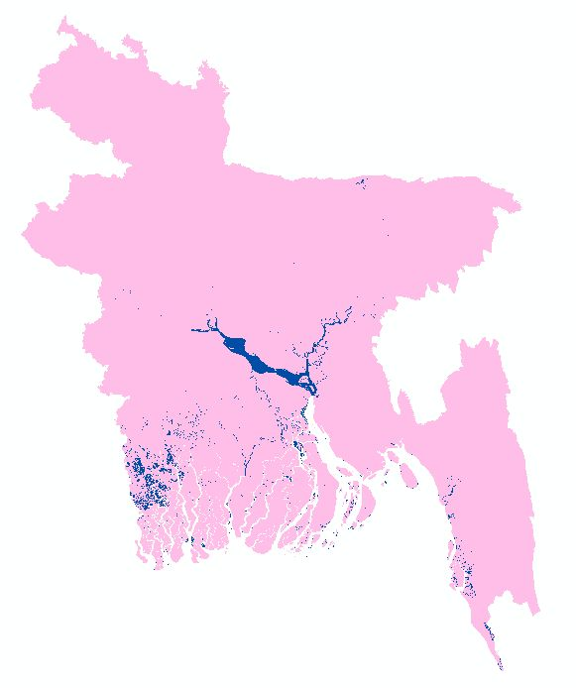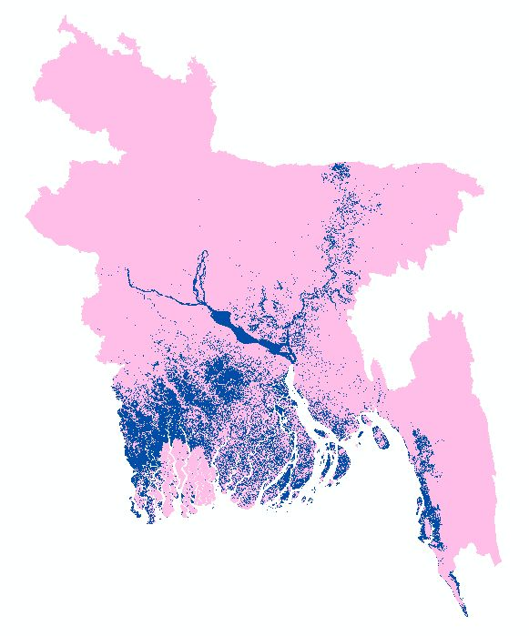

1 Meter Rise

5 meter Rise

*From these results, it is easy to identify the land that will be inundated if a one meter or five meter rise in sea level occurs. The next step is to calculate the number of people and the area of arable land that will be affected in each scenario. To do so, we will use Zonal Statistics.*

1. In the ArcToolbox, go to Spatial Analyst > Zonal. Double-click on the Zonal Statistics as Table tool.
2. In the Input Raster or feature zone data field, select the 1mRise raster. The Zone field should automatically default to ‘VALUE.’

*Note: The Values field (the 0s and 1s) defines what area will be affected by sea level rise, and what are will not be affected. So we’re going to sum up the population living in the ‘0’ zone (not affected) and the ‘1’ zone (affected).*

1. In the Input Value Raster box, select the population raster. Make sure the statistics type box is set to ‘SUM’ because we are adding up all the population that lives within the 1m sea level rise zone.
2. In the output raster field, save the new file as ‘Pop1mRise’ in your Lab 7 folder.
3. Once your Zonal Statistics as Table wizard looks like the following graphic, click OK.

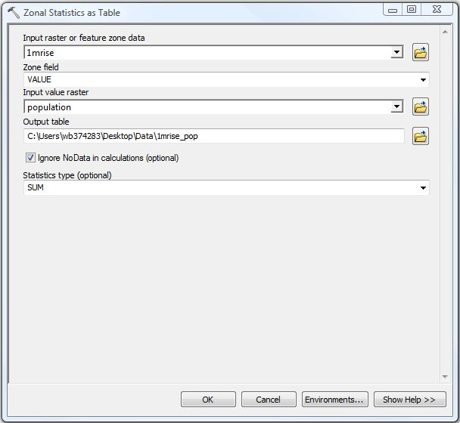

1. The new table of calculated statistics should appear in your table of contents. Right-click on it and open the attribute table to see the results.

*You essentially asked ArcMap to calculate the population that lies within both the inundated (value 1) and not inundated (value 0) cells. The ‘SUM’ field of the Zonal Statistics Table added up the population that falls within those cells.*

1. If you wish to determine how many people will be affected with a 5 meter rise in sea level, repeat steps 25 through 30 (but using the 5mRise raster and saving the table as Pop5mRise).
2. Open the two tables (if you calculated both) and compare the population affected by a 1m rise in sea level, and those affected by a 5m rise. These numbers can be found in the SUM column of the ‘1’ row.

*The next step in the process is to calculate the area of the cultivated land that will be affect by sea level rise.*

1. First, we must reclassify the land cover raster into agriculture and non-agriculture land. In the ArcToolbox, go to Spatial Analyst Tools > Reclass > Reclassify.
2. Use the ‘landcover’ raster as the input field, and ‘Type’ as the reclass field. Assign a ‘0’ to anything not listed as agriculture, and a ‘1’ to anything that is agriculture (there are four- Irrigated Intensive Agriculture, Irrigated Agriculture, Rainfed Agriculture, and Current Jhum- a type of slash and burn agriculture). Your reclassification box should look like this:

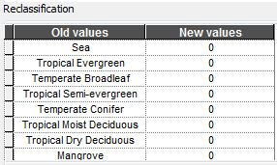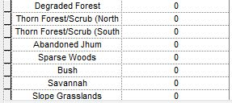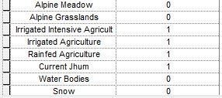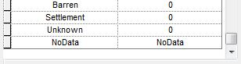

1. Save the output raster as Agri_reclass in your Lab 7 folder, then click OK to run the tool. It may take a few minutes to finish.

*The resulting raster should have two fields: 0 (those areas that are not agriculture) and 1 (those areas that are agriculture). Once again, we will use the Zonal Statistics as Table tool to determine how much agriculture land will be affected with a one meter rise in sea level.*

1. In the ArcToolbox, go to Spatial Analyst Tools > Zonal > Zonal Statistics as Table.
2. The input raster should be 1mRise. The Zone field should default to ‘VALUE.’
3. The input value raster should be Agri_Reclass.
4. Save the file as Agri1mRise in your Lab 7 folder, make sure the statistics type is set to ‘SUM’ and click OK when your wizard looks like the following screen:

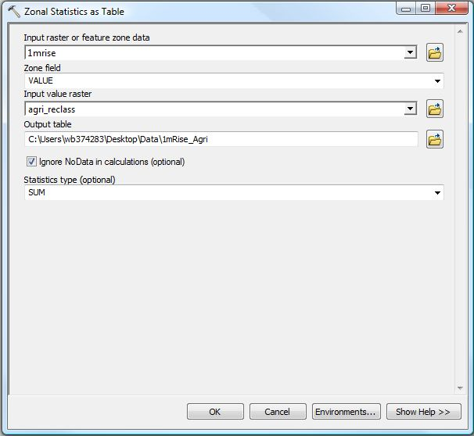

1. When the tool finishes, open the attribute table of the Agri1mRise table. The SUM field tells us how many pixels will be affected by one meter of sea level rise (value 1) and those that will not (value 0).
2. If you’d like to determine the amount of agriculture land affected by a 5 meter rise in sea level, repeat steps 36-40 with the 5mRise raster. Then, save your map.
3. Open the two tables (if you calculated both) and compare the results. Remember, in this instance we’ve summed the number of agricultural pixels inundated by sea level rise. If you wish to calculate the actual area of land affected, you need to project the raster into an appropriate projected coordinate system, check the properties to determine the area of each pixel, then multiply the number of pixels inundated by the pixel area.

*Congratulations! You have now successfully used your three rasters to determine how many people and how much land will be affected under certain sea level rise scenarios.*

**PART 2 - Proximity Analysis using Raster Data**

*You have been asked to generate report statistics outlining accessibility to rural hospitals in Malawi. You have a raster dataset of population, and a ‘rural hospitals’ point file. You will use the Spatial Analyst toolbox in ArcMap to generate a hospital distance raster, and then the Zonal Statistics function to calculate the population located within each distance zone.*

1. Open a new, blank ArcMap session. Add the two files found within the Lab 7B folder- a raster (Malawi_pop) and a point file (RuralHospitals). **Save your map as Map 7b within the Lab 7b folder, and remember to save periodically throughout the exercise.**

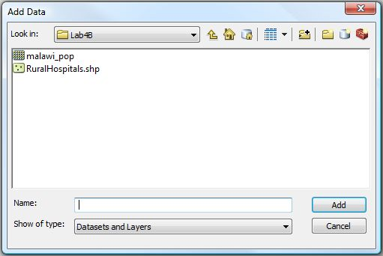

1. Malawi_pop is a raster, extracted from the global Landscan 2012 dataset. It has been projected using the UTM Zone 36S coordinate system, one of the most accurate for measuring distances in Malawi. As a result, cell size has been reduced from 1km to roughly 920m (it has become more accurate due to the projection).
2. The default coloring of a raster is black to white- to change the symbology, double click on the Malawi_pop layer name.
3. In the Symbology tab, choose a brighter color ramp, and make sure the “Display Background Value” box is checked. This means that all cells with zero value will be transparent.

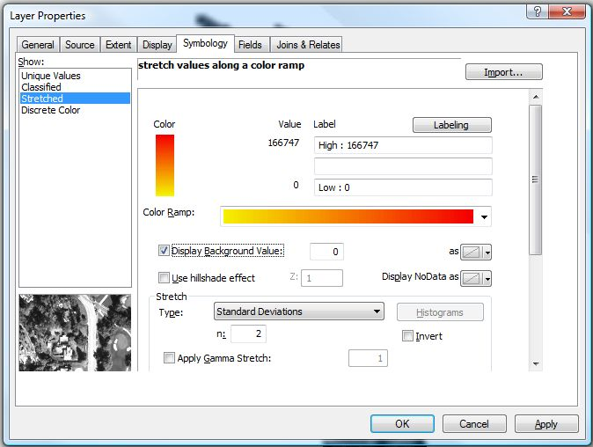

1. Click OK to view the symbolized raster.
2. In the ArcToolbox, go to Spatial Analyst Tools > Distance, and double click on the Euclidean Distance tools. (Euclidean means straight-line distance.) If you cannot open the tool, go to the top menu bar and select Customize > Extensions. Make sure the Spatial Analyst extension is turned on.
3. We are measuring distance from the hospitals, so select RuralHospitals as the input feature source.
4. Click the folder to the right of the output distance raster box and navigate to the Lab 7b folder. Save the raster as ‘Hospital_Dist.’
5. Leave the maximum distance box blank.
6. Leave the output cell size as it is- 918.58m (the size of the projected raster cells).
7. When your Euclidean distance wizard looks like the one on the following page, click OK. (It might take a few minutes to process.)

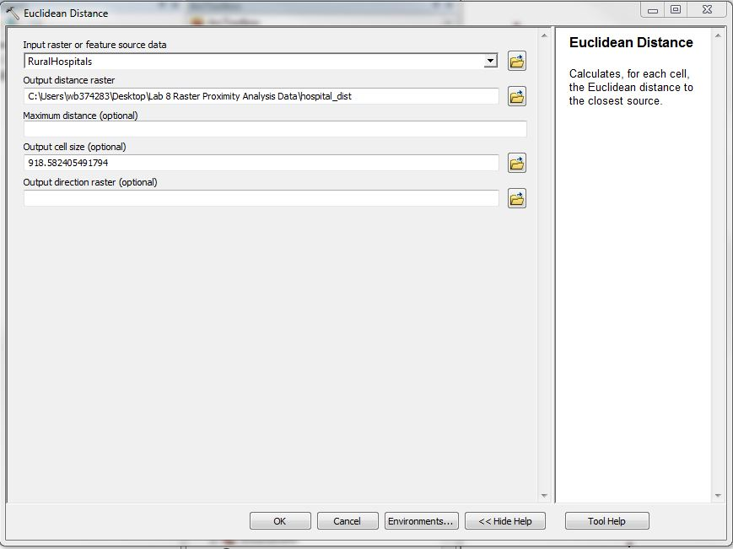

1. The output should automatically appear in the map display, and should look something like this:  
   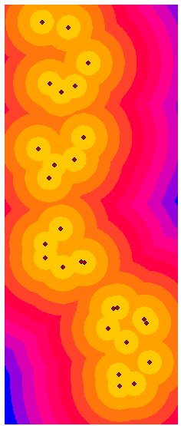
2. By default, ArcMap displays the new raster in 10 categories. To change this, double-click on the new ‘Hospital_Dist’ layer name.
3. On the Symbology tab, change the number of classes to 6, then click on the ‘Classify’ button.
4. We want to find out how much of the population lives within 1km, 5km, 10km, 20km, 50km, and >50km of a hospital. To visualize this, change the classification method to ‘Manual’ (use the drop down menu at the top of the dialogue box; it should be currently set to Equal Interval).
5. 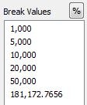In the Break Values box, enter the values as seen in the box on the left.

*NOTE: Remember, we are working in meters since those are the units of the original shapefile.*

1. Click OK twice. Your output should look like below- if you’d like, turn off the hospital points (uncheck the box next to the layer name) to get a better look at the classes.

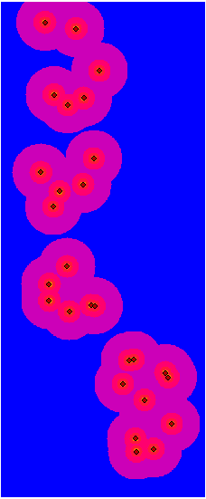

1. The re-categorization is merely cosmetic at this point. To formalize it, we will create a new raster product.
2. Go to the ArcToolbox. Select Spatial Analyst Tools > Reclass > Reclassify.

1. In the ‘Input Raster’ field, choose ‘Hospital_Dist’ from the drop-down menu. The default values for the rest of the tool should be fine- ArcMap has automatically matched the classification breaks we just entered into the symbology tab. Cells with values of 0-1,000m are now 1; cells of 1001-5000m are 2; etc.
2. Save the output raster as Hospital_Clas inside the Lab 7b folder.

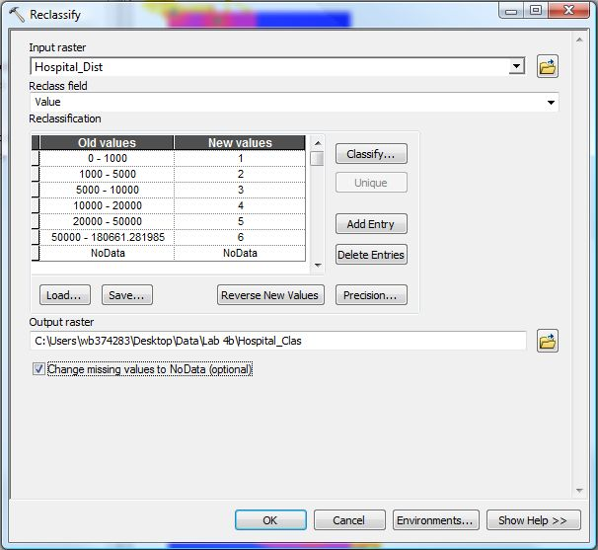

1. Once your screen looks like the one above, click OK. Remember, the tool might take a few minutes to process.
2. The output raster should automatically add to the display when it is finished. Visually, the pattern of the new data will look much like the “Hospital_Dist” set, but the cell values have been simplified into 6 broad categories.

*Now that we have a correctly classified distance raster, let’s calculate how much of the population falls within those distance classes.*

1. In the ArcToolbox, go to Spatial Analyst Tools > Zonal > Zonal Statistics as Table.
2. Populate the tool so that it looks like the one below. Name the output file Hosp_Dist_Pop and save it within the Lab 7b folder.

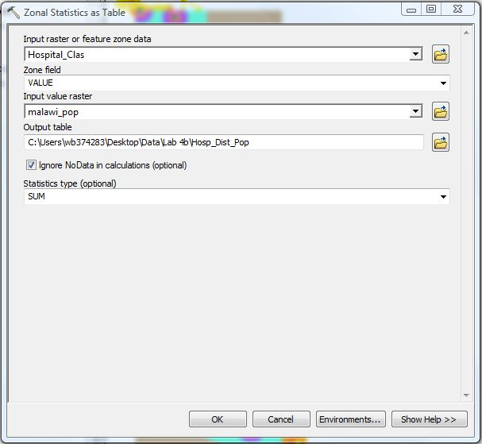

*Essentially, you are telling ArcMap that for each Value (Classes 1-6) in the “Hospital_Class” raster, you wish to tally the sum of values from the corresponding cells in the ‘Malawi_Pop’ raster. The result will give you the total population count in each of the 6 classes, or zones.*

1. Open the attribute table of the new table. Scan through the total population living within each zone.  
   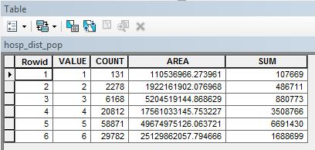
2. To create a graph that displays the information, click on the top left-hand ‘options’ and scroll down to ‘create graph.’

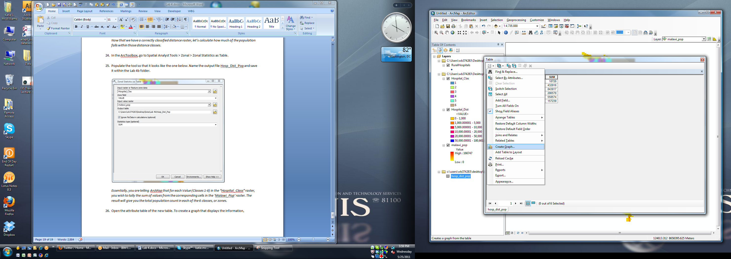

1. In the drop down box next to ‘Value’ field, select SUM. In the X Field (optional) drop-down, select VALUE.
2. To change the colors, select ‘Palette’ from the drop down menu next to Color. In the box to the right of ‘Palette,’ explore the different options and select any color group you like. Your graph wizard should look like this:

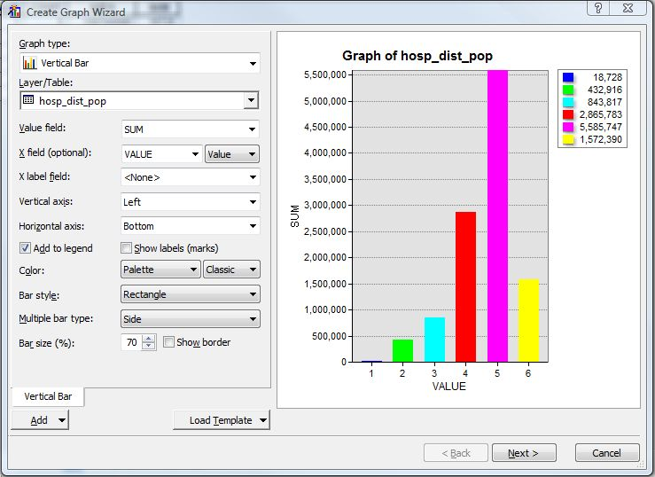

1. Click ‘Next’ twice to accept the rest of the defaults. The final graph should appear on your screen.
2. From this image, we can easily see that a large number of people (6,691,430) live in zone 5- which was between 20 and 50km from one of the hospitals. 1,688,699 live further than 50km from a hospital.

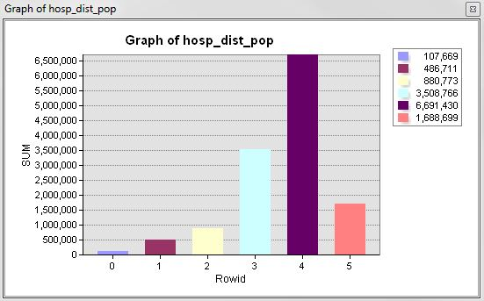

*Congratulations! You have now used raster-based spatial analysis processing tools to calculate how far the people of Malawi live from hospitals. Save your work, then exit out of the program.*

**Extra Credit:**

Inside the extra credit folder, you’ll find a nighttime lights composite image from 2010 (a freely available dataset downloaded from NOAA), as well as an administrative 1 (oblast level) shapefile for Ukraine. Using all the skills you have learned today, create a publication-quality choropleth map that shows the total nighttime lights, by district, for Ukraine.